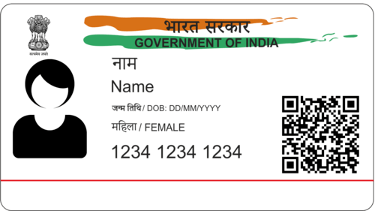





# Name = XXXXXX

# DOB = 16 / 7 /2008

# GENDER = FEMALE

# 1234 5643 1234

Uyhg

gdf



